INTERNAL QUALITY ASSURANCE CELL (IQAC)
N. N. GHOSH SANATAN TEACHER TRAINING COLLEGE
Jamuary, Kanke, Ranchi, Jharkhand
EVENT REPORT: CLEANLINESS & SANITATION DRIVE
Special Campaign 6.0 – 2026 | Day 3 of 6

1. Event at a Glance
Event | Cleanliness & Sanitation Drive
Programme | 6-Day Swachhata, Environmental Awareness & Sustainability Programme (Special Campaign 6.0–2026)
Organised by | College, in association with IQAC
Date & Day | 3 October 2026, Saturday
Scheduled time | 10:00 AM – 1:00 PM
Venue | College building entrance, garden, pathways and surrounding campus area
Chief guidance | Principal, Dr. Dhananjay Prasad
Participants | Teaching faculty, non-teaching staff and B.Ed. students
Notice reference | Notice dated 30 September 2026
2. Photo Documentation
GPS-stamped photographs (Jamuari, Jharkhand · 3 Oct 2026 · 12:24 PM – 12:37 PM) as evidence for IQAC records.
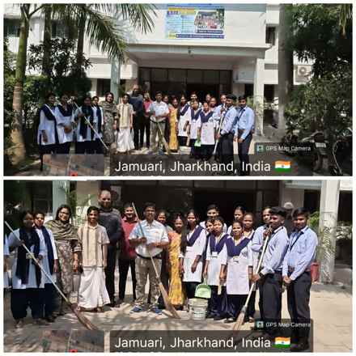
Principal, faculty, staff and students at the college entrance with brooms and buckets before the drive
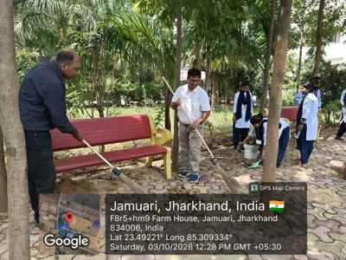  Principal and a faculty member sweeping the garden pathway with students | 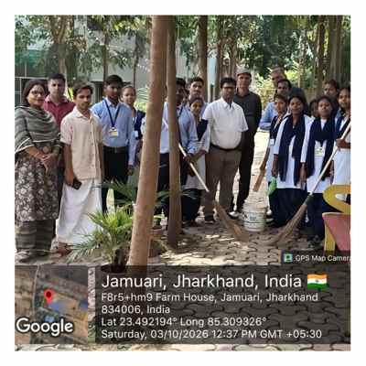  Team group photograph in the campus garden after the drive

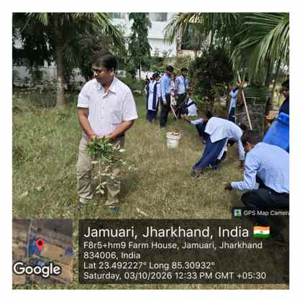
Clearing weeds and wild grass from the lawn
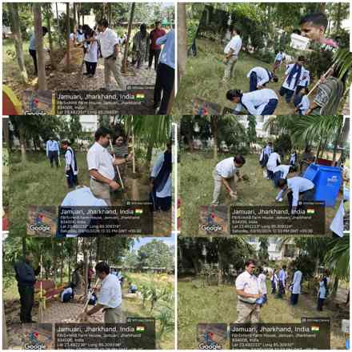
Group-wise cleaning in action: pathways, lawns and waste collection
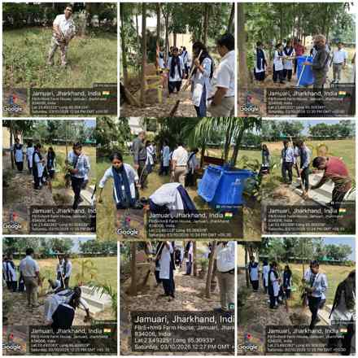
Students, staff and faculty working together across the campus
3. Proceedings of the Day
- Opening & motivation. The Principal, Dr. Dhananjay Prasad, addressed the gathering and inspired the students to keep not only the college but also its surroundings clean, stressing that cleanliness is a daily responsibility and a habit, not a one-day activity.
- Group formation. Participants were divided into groups, and each group was assigned a specific zone of the campus.
- Cleaning in action. Groups swept pathways and the seating area, collected dry leaves, cleared weeds and wild grass from the lawns, tidied steps and garden beds, and gathered waste.
- Waste handling. Collected waste was put into buckets and the dustbin provided for proper disposal, so that the cleaned areas stayed clean.
- Group photograph & closing. The drive ended with a group photograph in front of the college building and a collective resolve to continue the effort.
4. Impact & Outcomes
- A visibly cleaner, safer and more welcoming campus.
- Strong team spirit among leadership, faculty, staff and students.
- Students learned dignity of labour and practical sanitation habits.

IQAC Coordinator |  | Principal  Dr. Dhananjay Prasad

